1. Examination – pag save and exit ko automatic move to BI na.walana option to add exam. Pwedeba wag automatic move to BI pag exit? Done

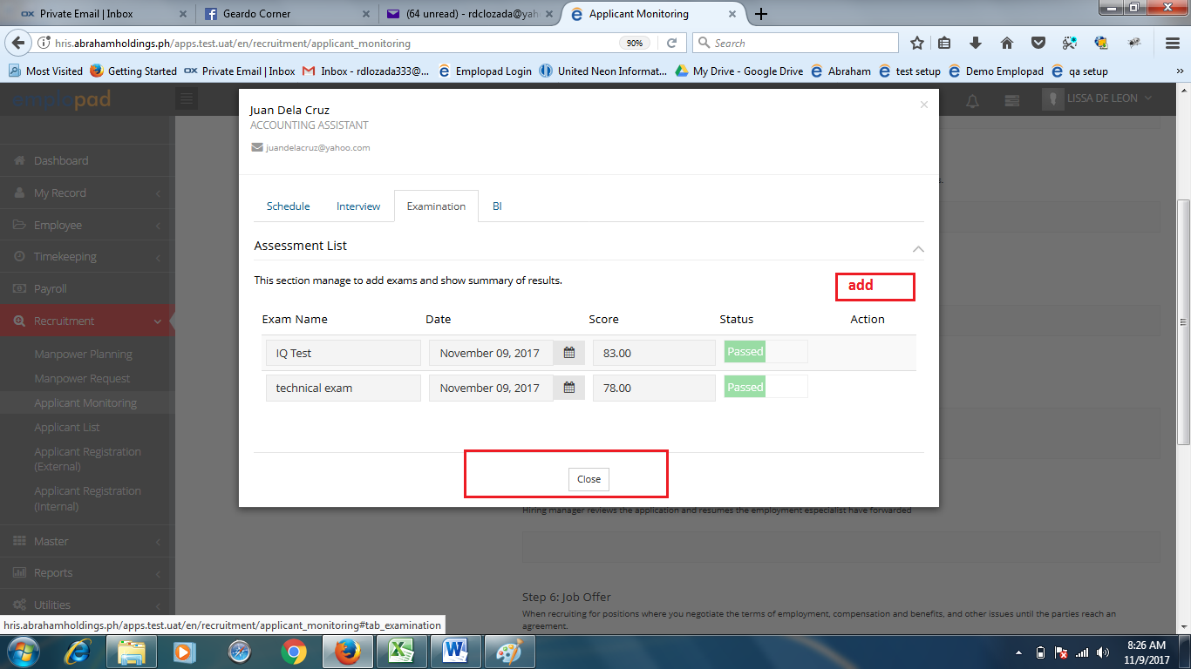

1. BI Printing – naka hardcoded ung page number ☺ Remove - Done

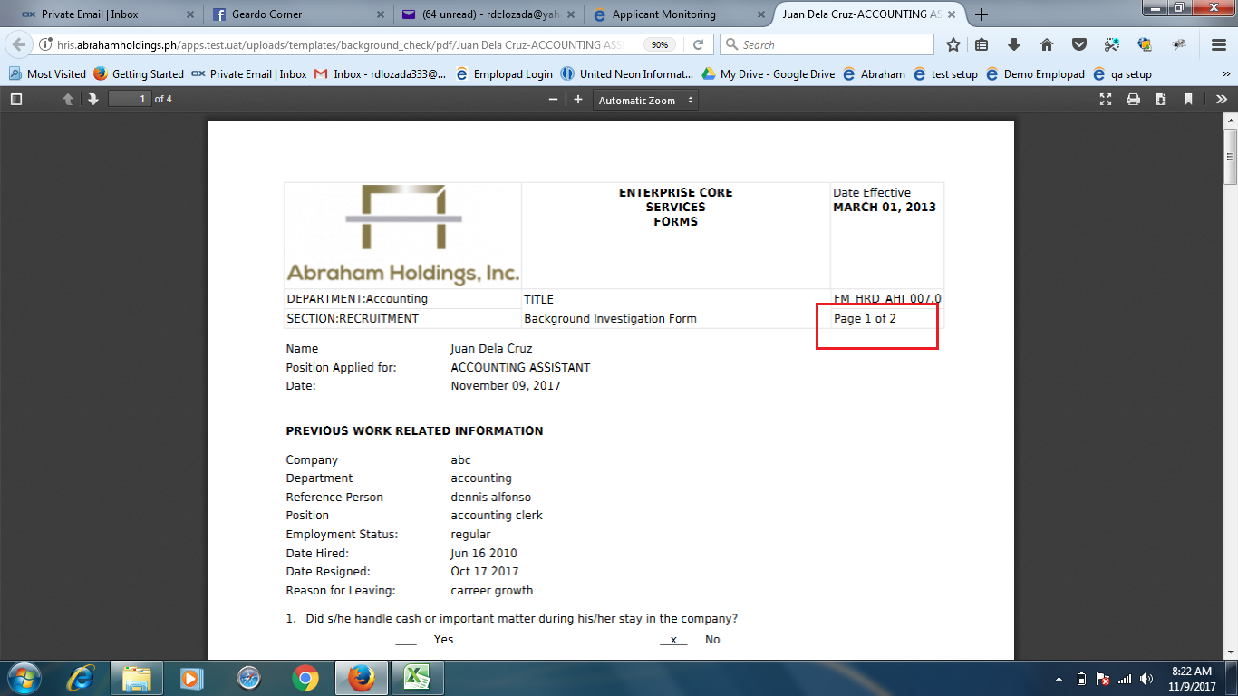

Continuous ung printing kapag multiple BI.Lakihannalangnatin space per BI (kahit 5 spaces) Di pwede masyado malaki space paps kasi same lang siya kahit 1 page lang. Done

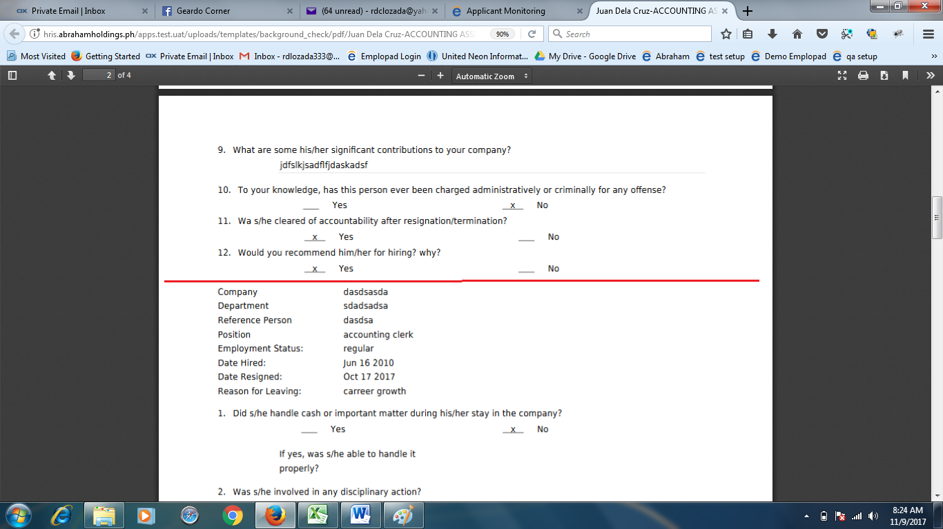

1. 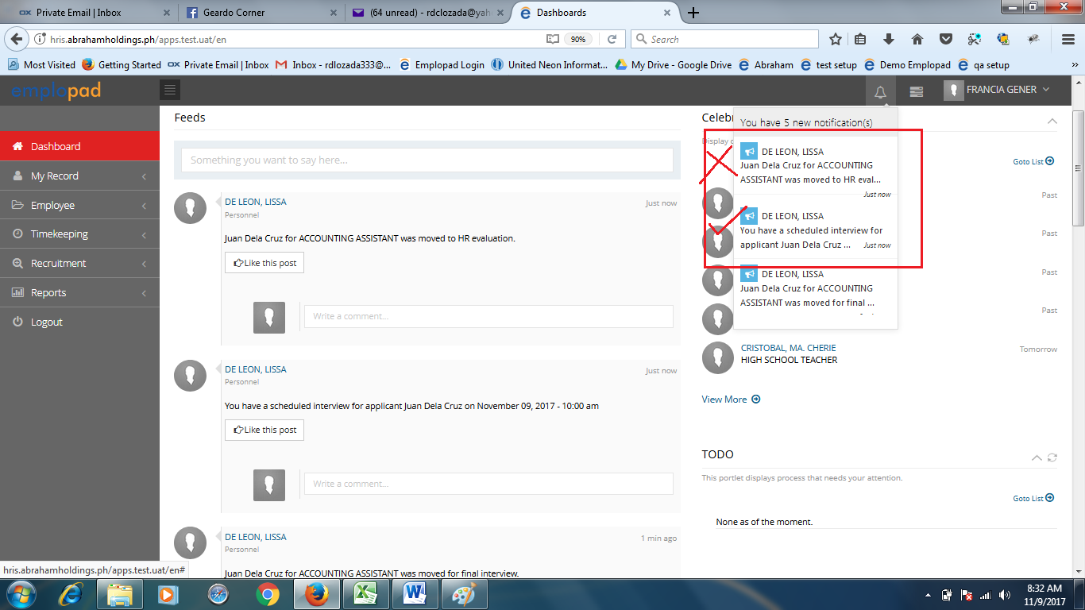Final Interview – 2 na received na notification. Ungisang notification bakadahilbumaliksasa step 2. Kaseungnotifparakayhrun. See screenshot below. Done
2. Interviewer attachment – laging 2 ung file nanaaupload. (Done nahirapan ako ditto. Hehehe)

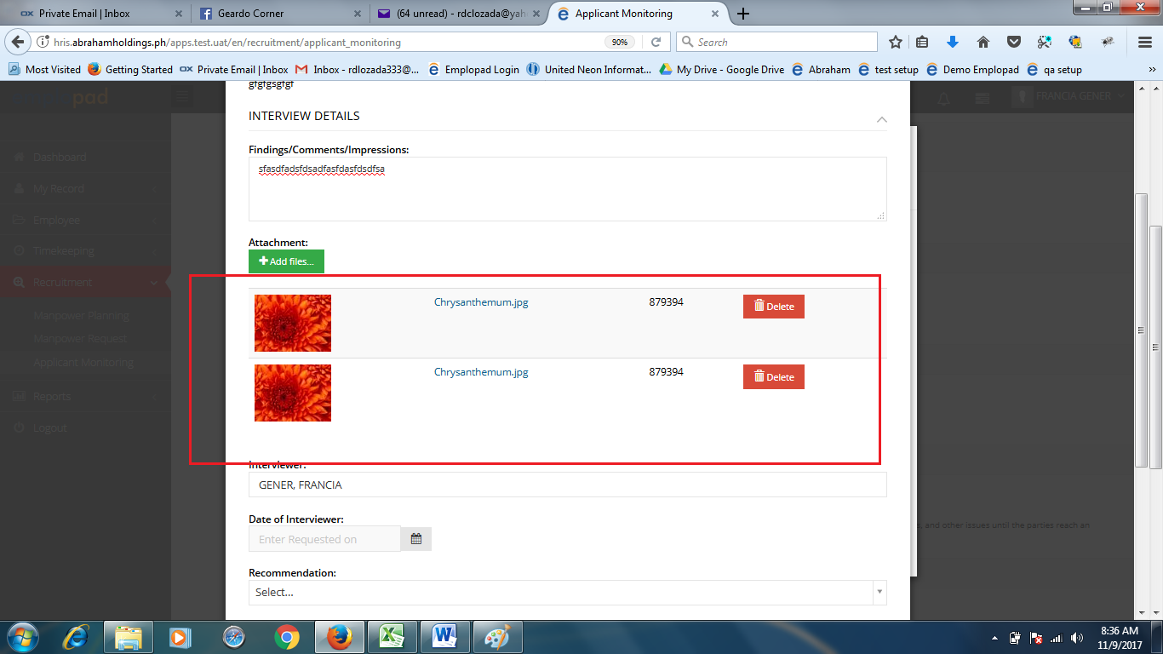

1. Interviewer – dapat read only lang Done

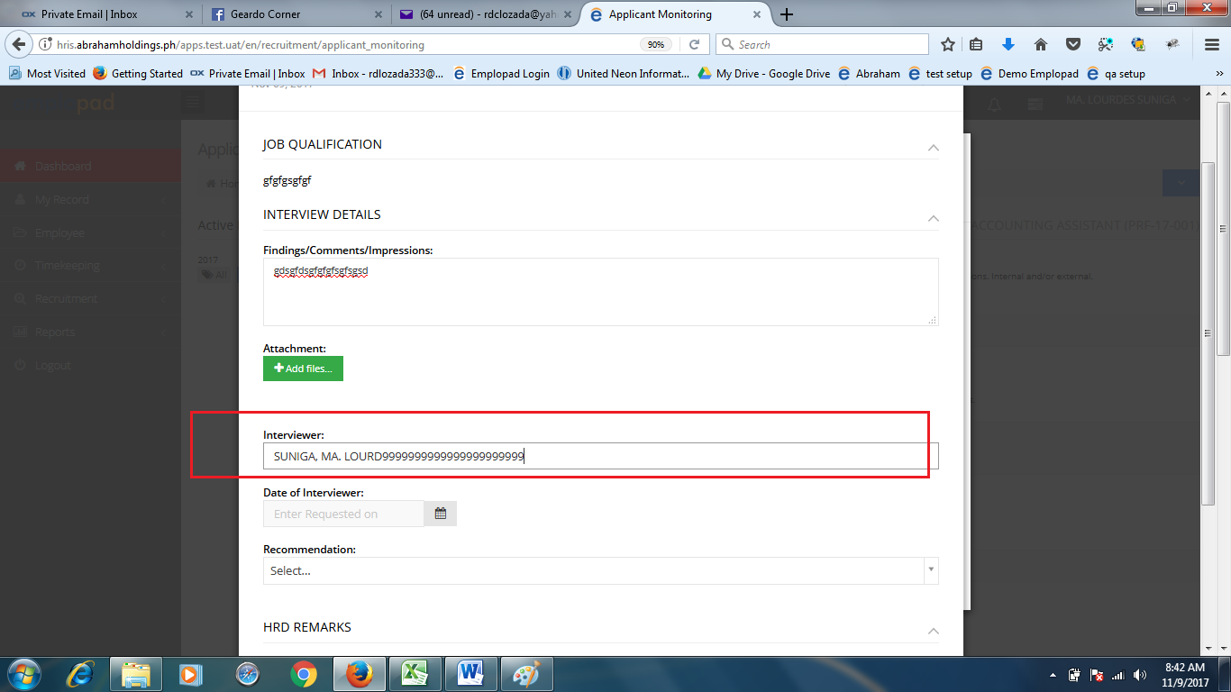

1. 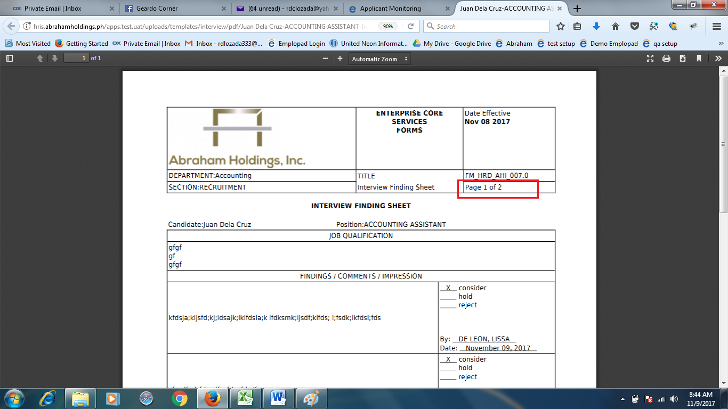Interview finding sheet – naka hardcoded ung page number. Remove - Done
2. Dapatatapaps nag eemailnotifkay HR everytime may nag entry na final interviewer? Sa ngayon wag na muna paps kasi meron din disadvantages yan, kasi tingin ko dapat ang meron lang notification eh yong need umaksyon. So kung magtataka si hr bakit wala pa dumarating pwede naman niya puntahan yong applicant monitoring. Pero kung every time meron darating sa kanya masyado rin marami yon. Kapag ni request na lang nila paps.
3. Job offer – auto comma (,) dapayung amount paps. Done

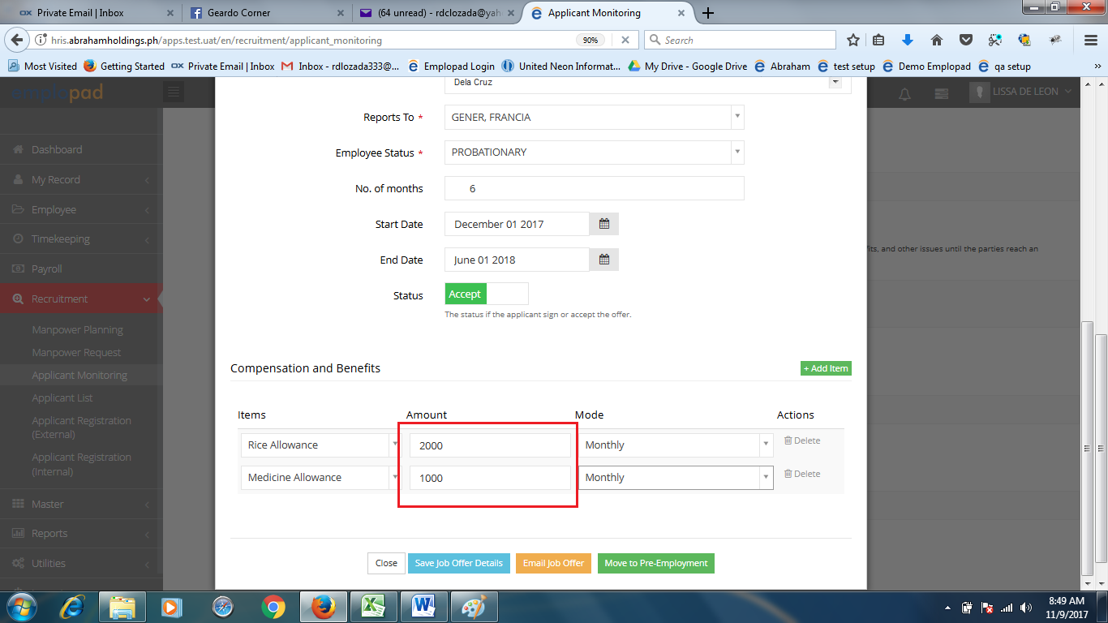

1. Job offer email – wala pa ung body? Wala pa paps kasi di ko alam ano ilalagay ko

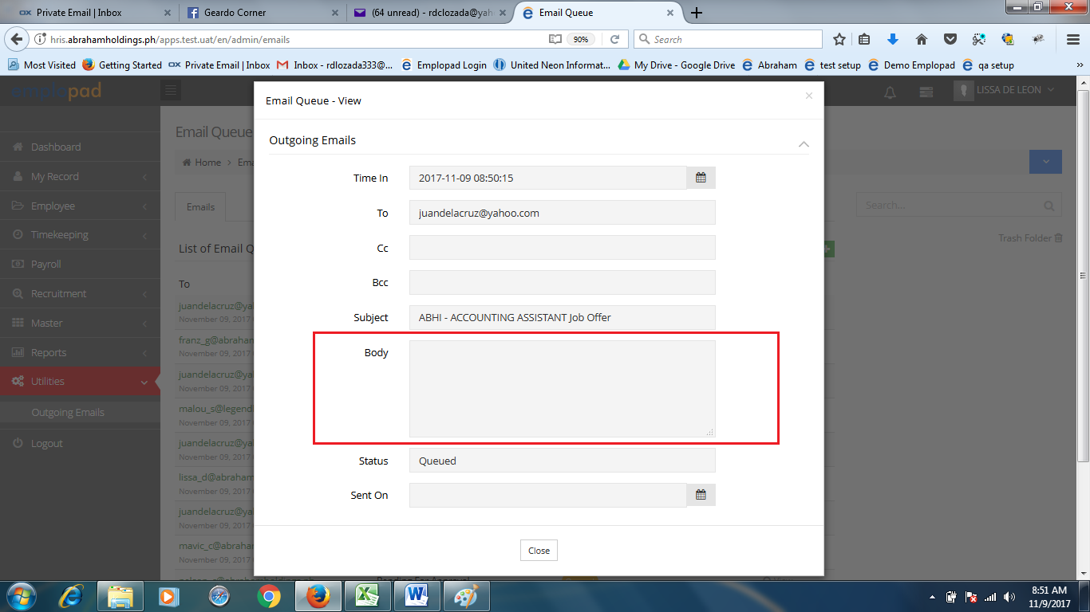

1. Pre-employment – hindikitaung year sa date. Pa-adjust paps. Anubanapagagreehan? Lalagyanng save button? Ngayonkasekailangandiretso move to create 201 para ma save ung entries. Ang napag agreehan natin hindi lalagyan, as is na kasi sa kanila di naman talaga pwede tumuloy kung hindi complete. Year - Done

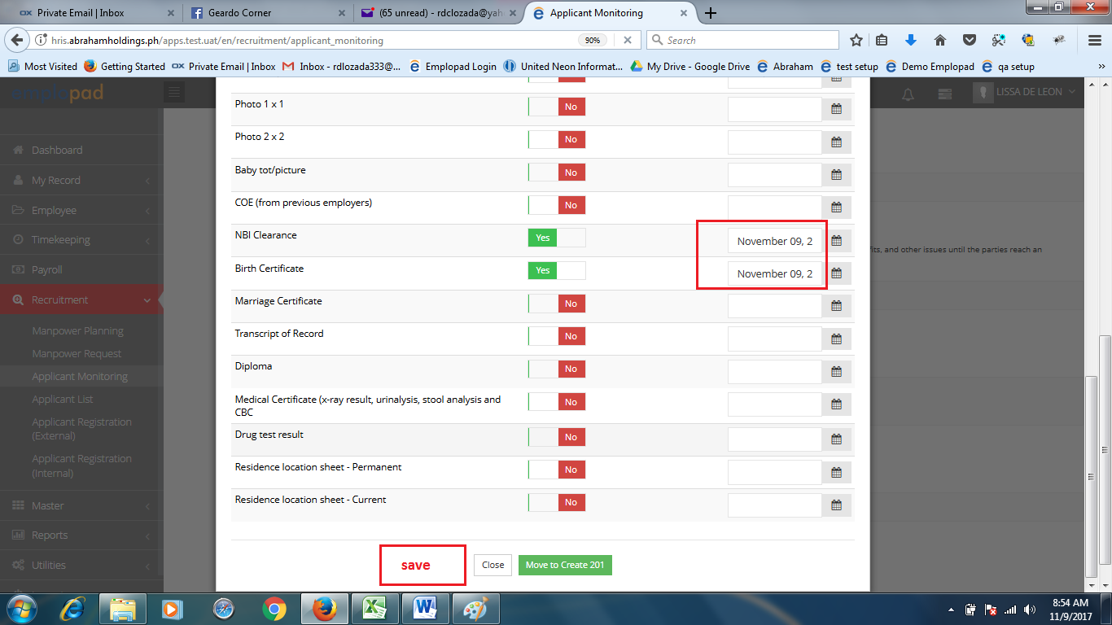

1. Create 201 – weekly shift ungdapatnalalabassa work schedule picklisthindi shift. Done

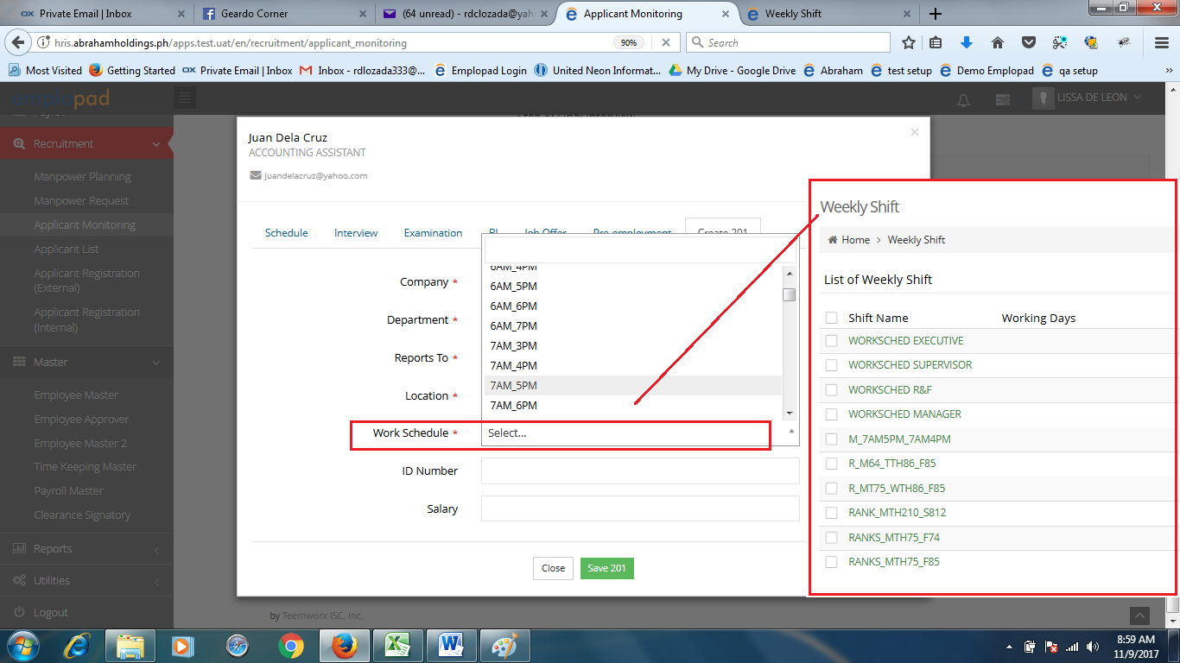

1. Applicant list (history)

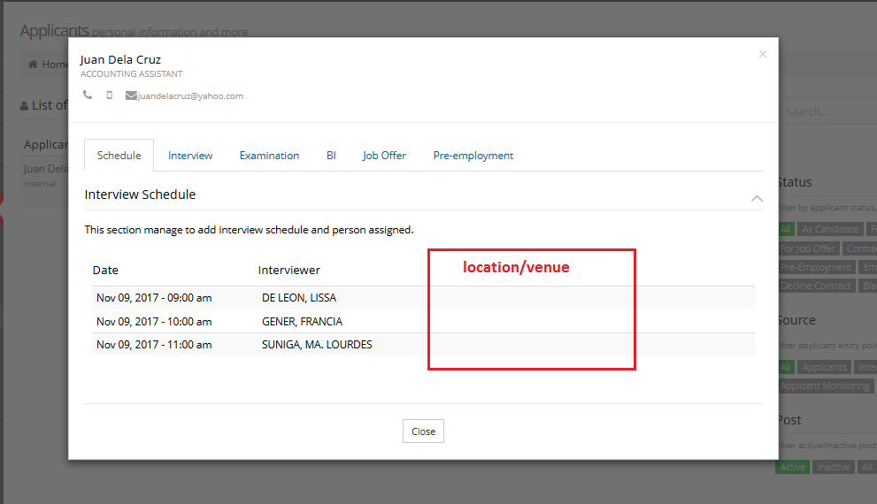Interview schedule – hindilumabasung location Done

Interview tab – not working ung view button and dapat active pa din print button. Done

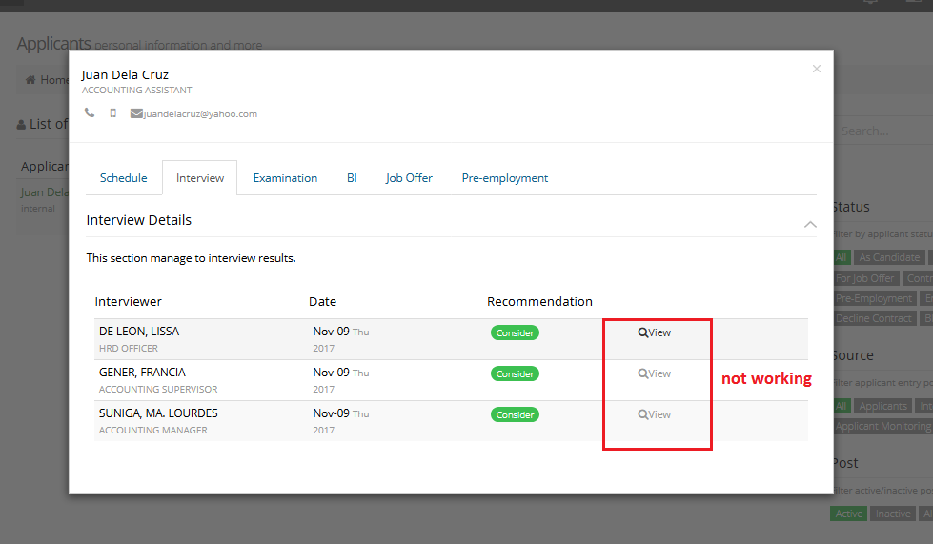

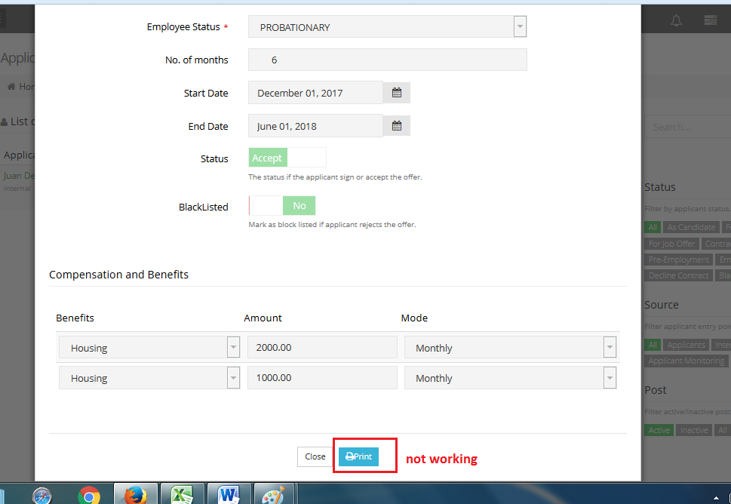Job offer – print button not working . Working siya

1. Applicant list (Employee data sheet printing) – hindi pa nakalagayung format niahi. Namali ako ng naupdate na template. Pero ok na

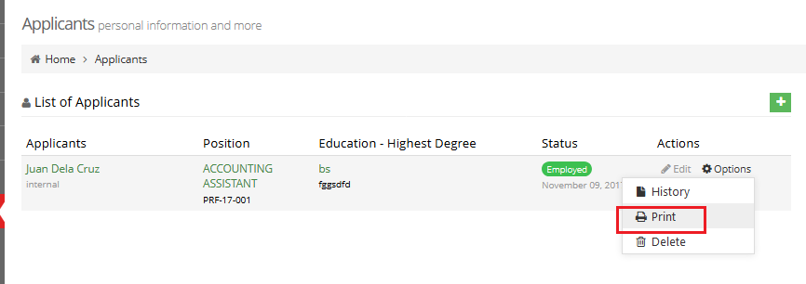

Standard format

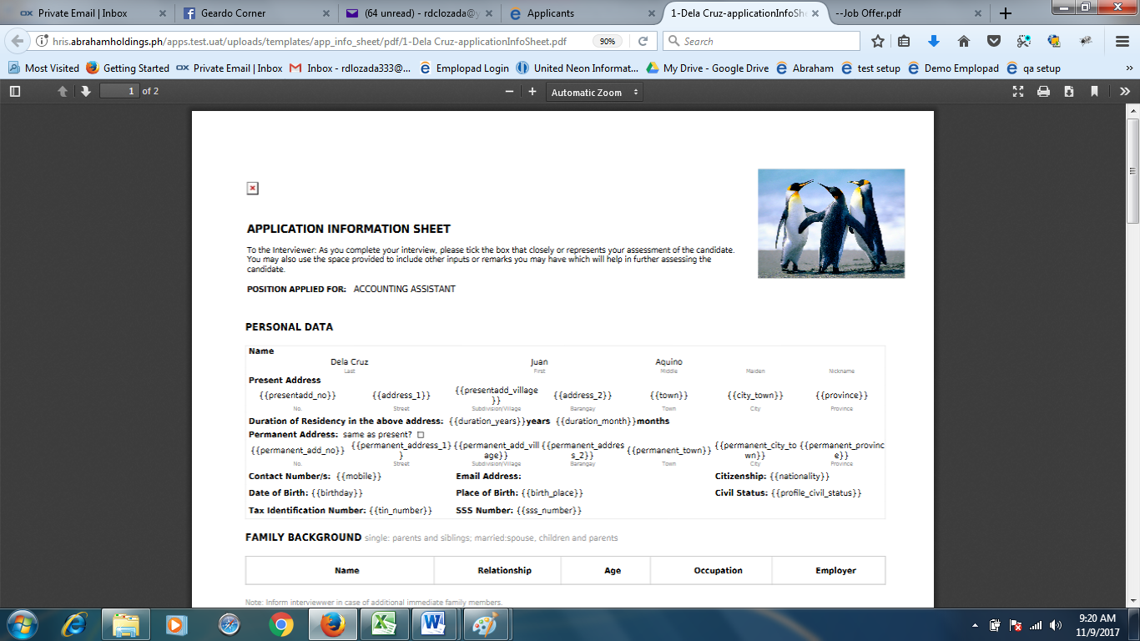

Ahi format

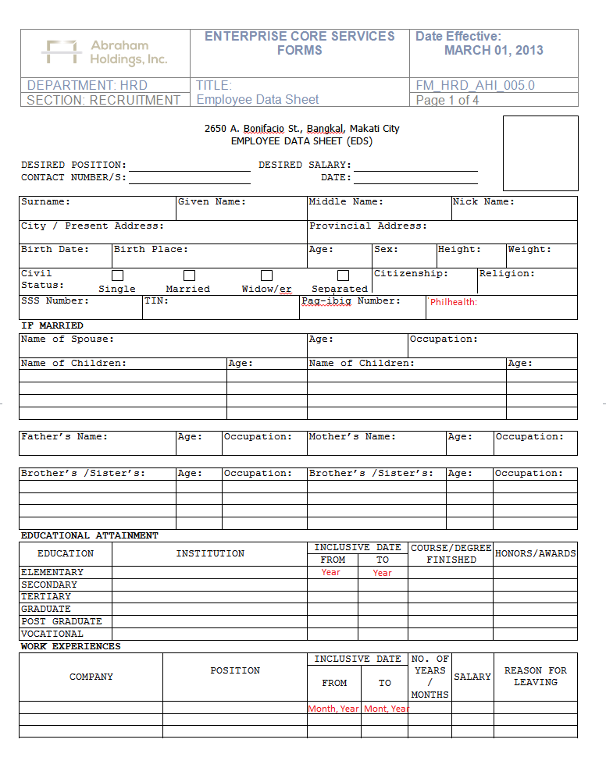

Addition field for Philhealth I.D.

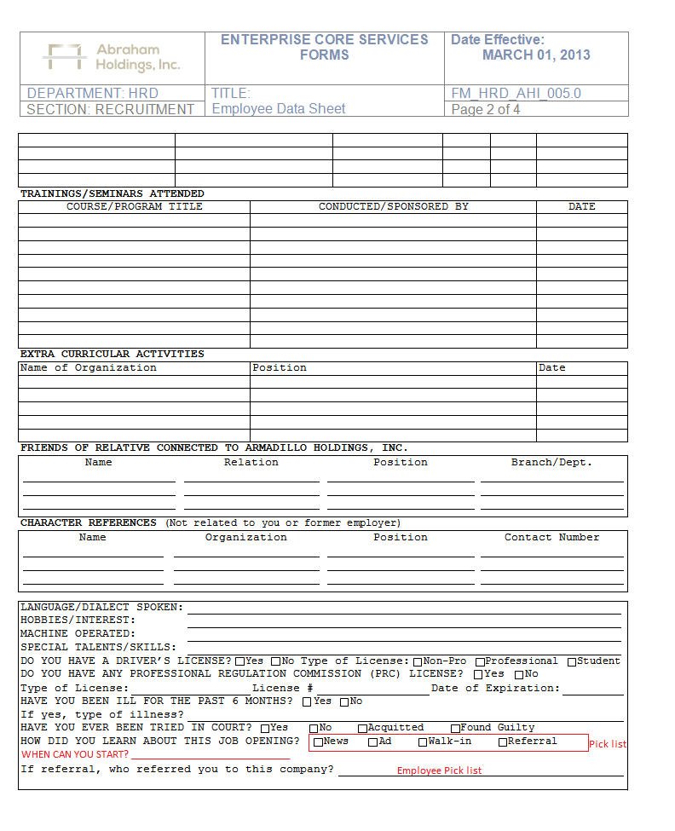

Additional field for the start date

Pick list w/ Master file entry

From employee pick list

1. Applicant list vs. employee list. Pagusapan natin ito kung papaano. Kasi base sa design nito hindi naman talaga the same sila.

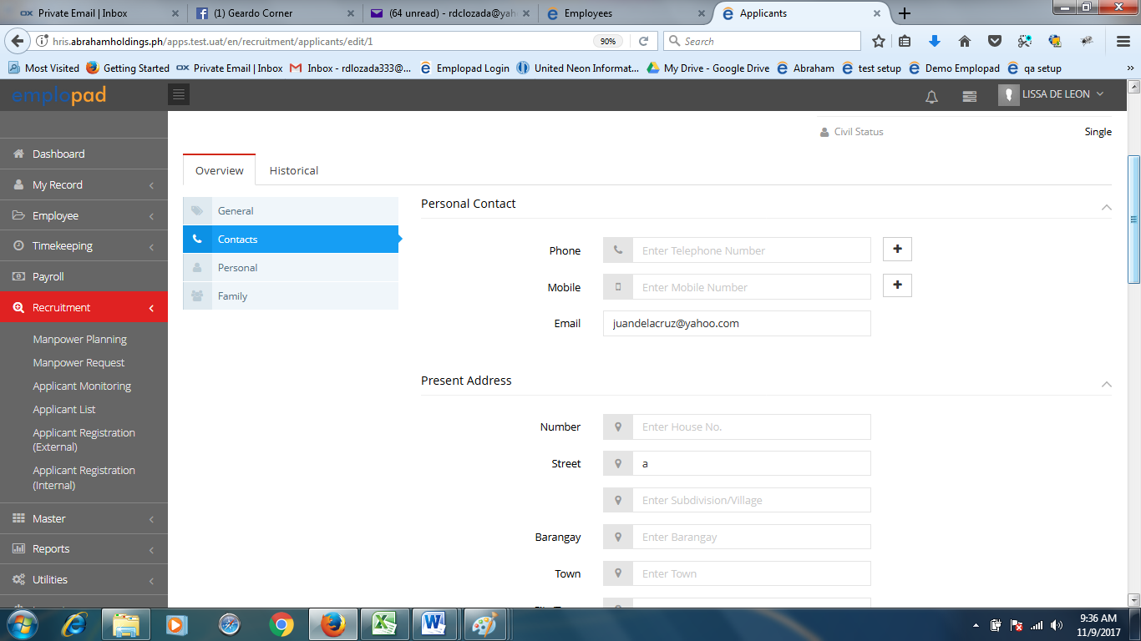Contacts – sa applicant list meron present at permanent address sa employee list isang address lang

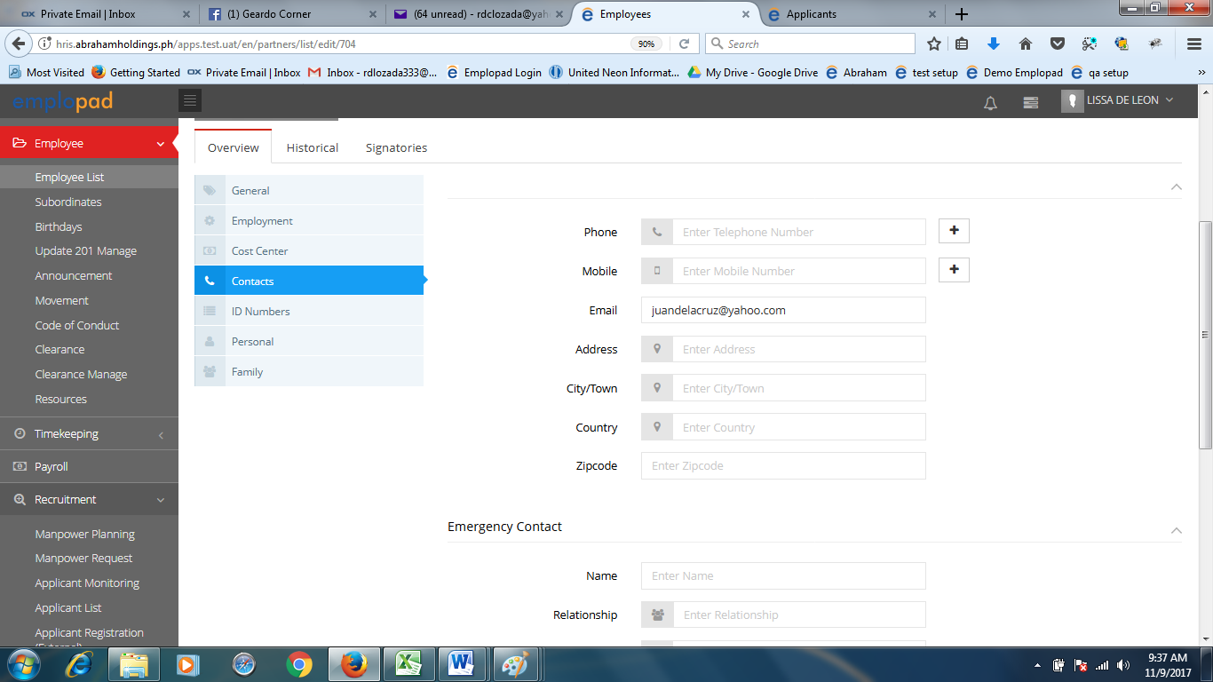

DETAILS PER TAB ON EMPLOYEE LIST AND APPLICANT LIST TO FOLLOW…..